Day 6 Lab
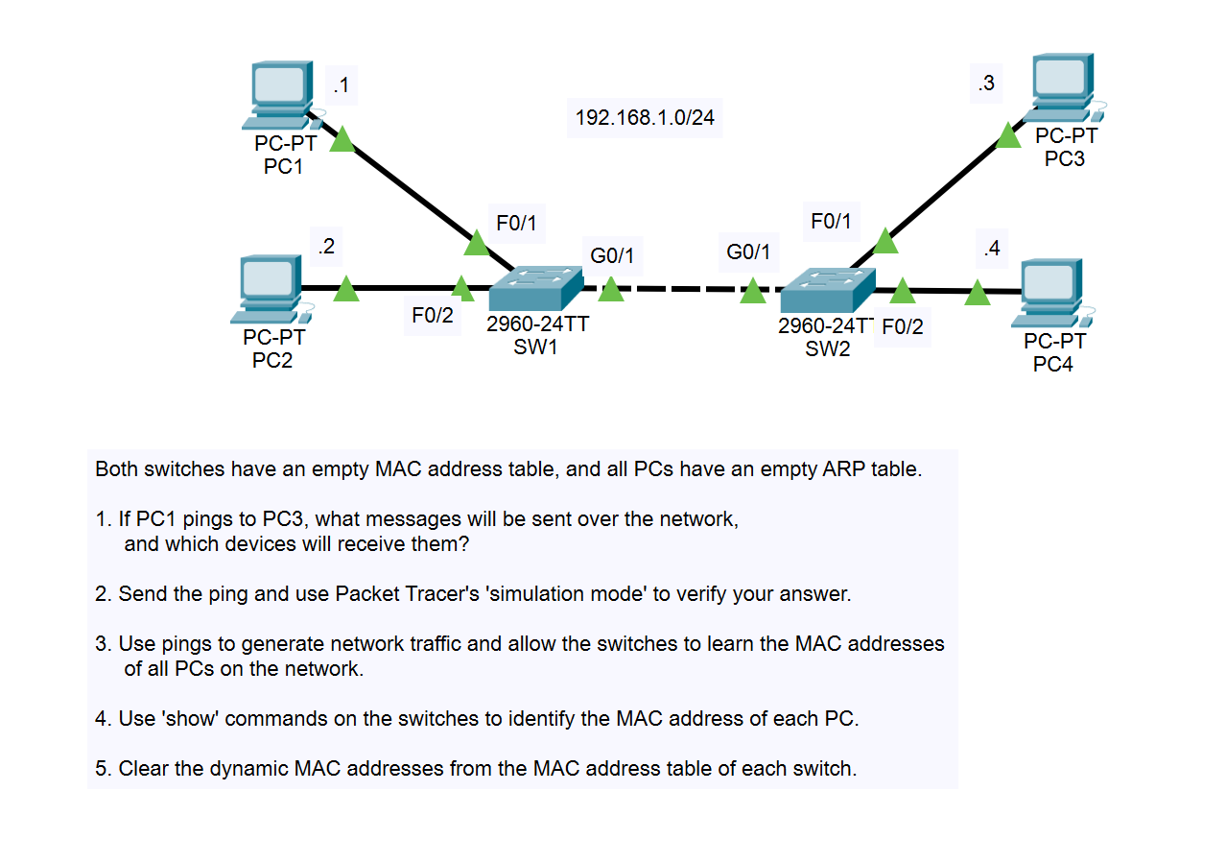
Step 1:
- ARP Request (received by PC2, PC3, PC4) – Broadcast message
- ARP Reply (received by PC1) – unicast message
- ICMP Echo Request (received by PC3) - unicast message
- ICMP Echo Reply (received by PC1) - unicast message

Step 3:
PC1
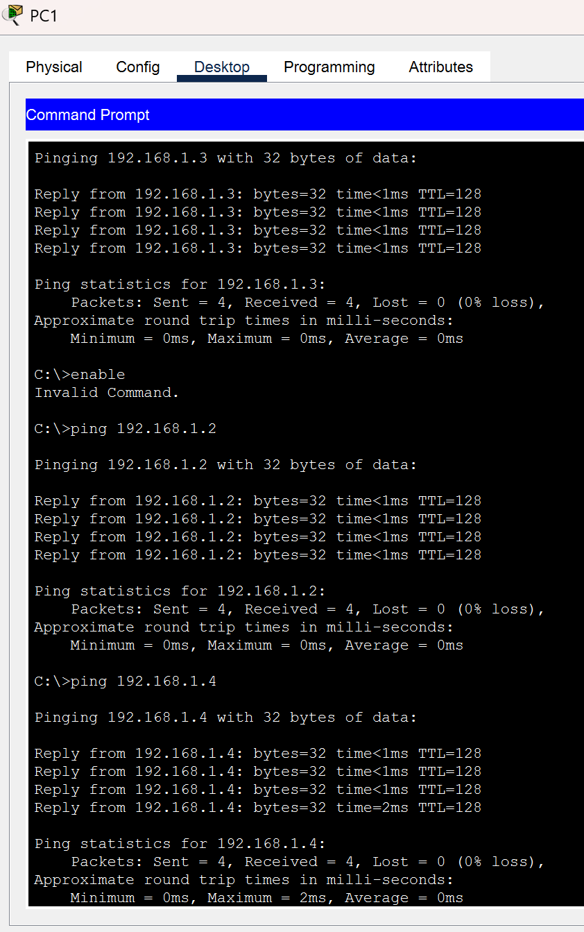

PC2
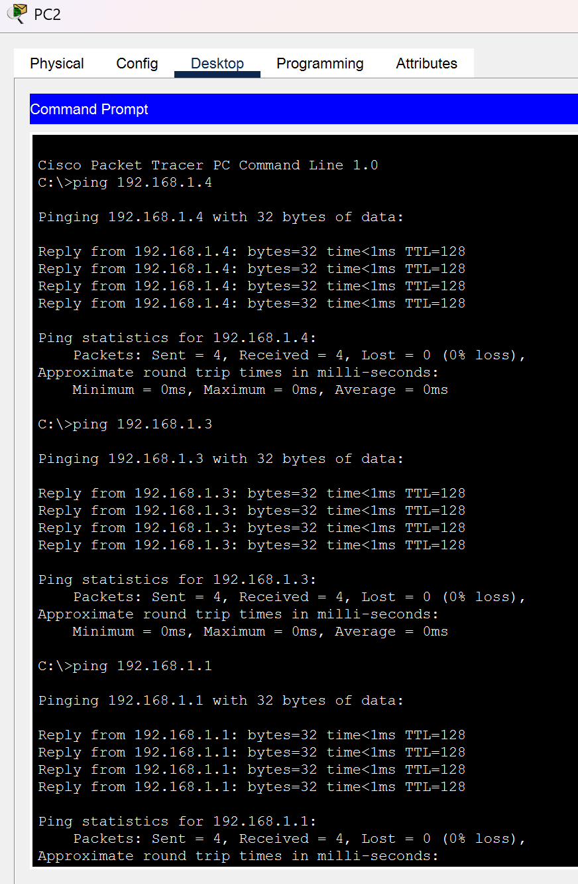

PC3
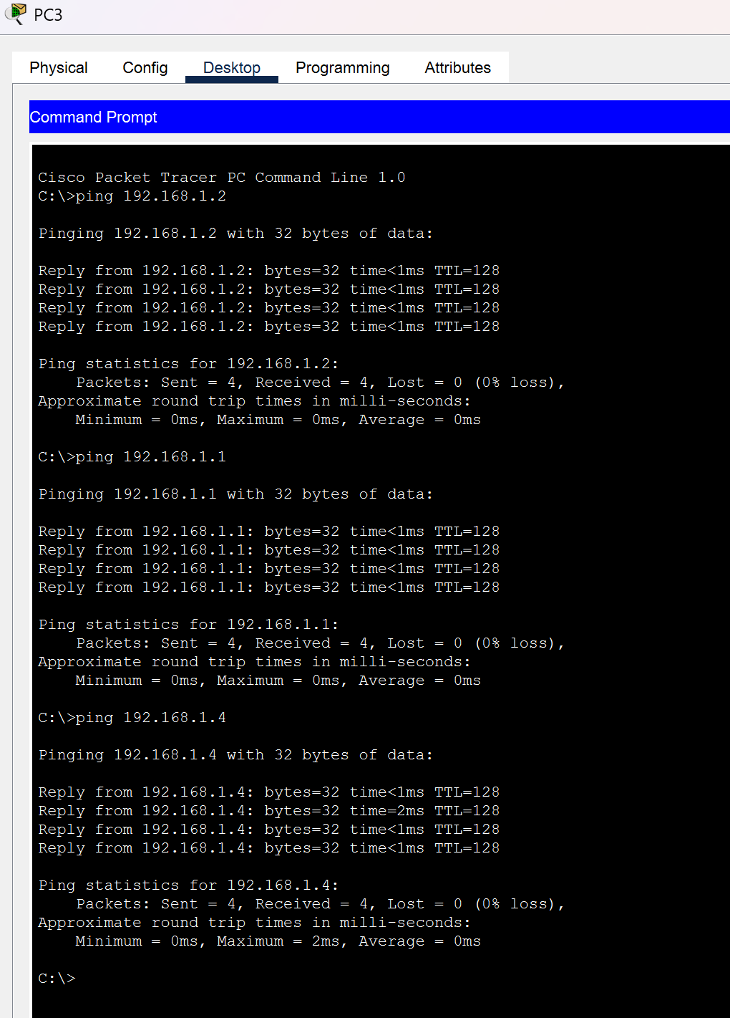

PC4
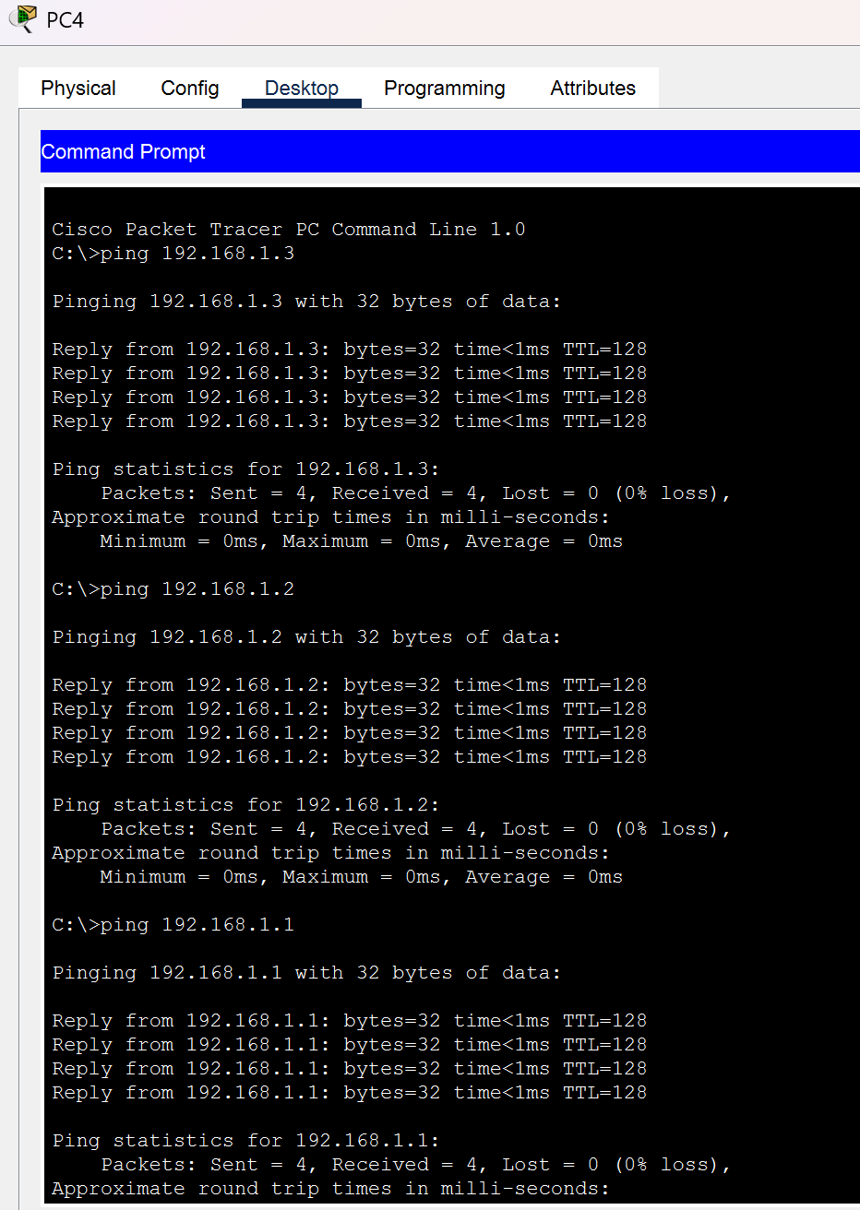

Step 4:
Switch 1
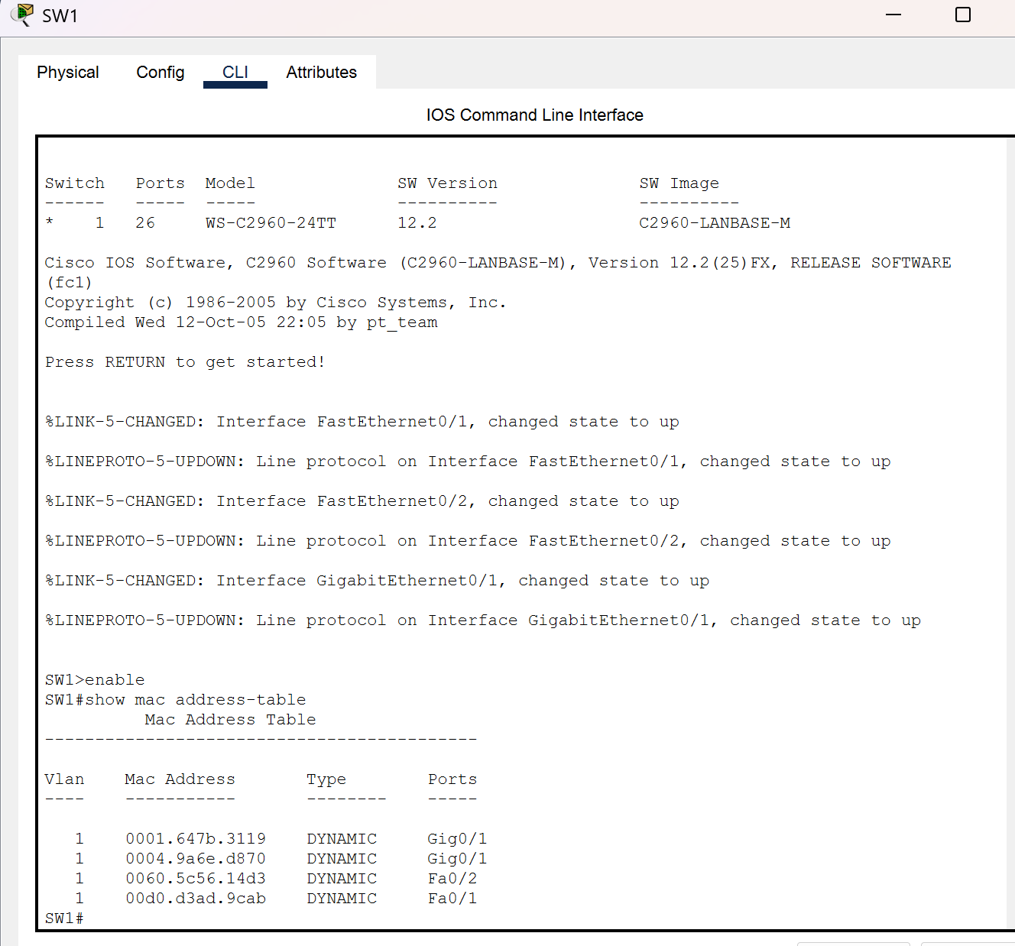
Switch 2
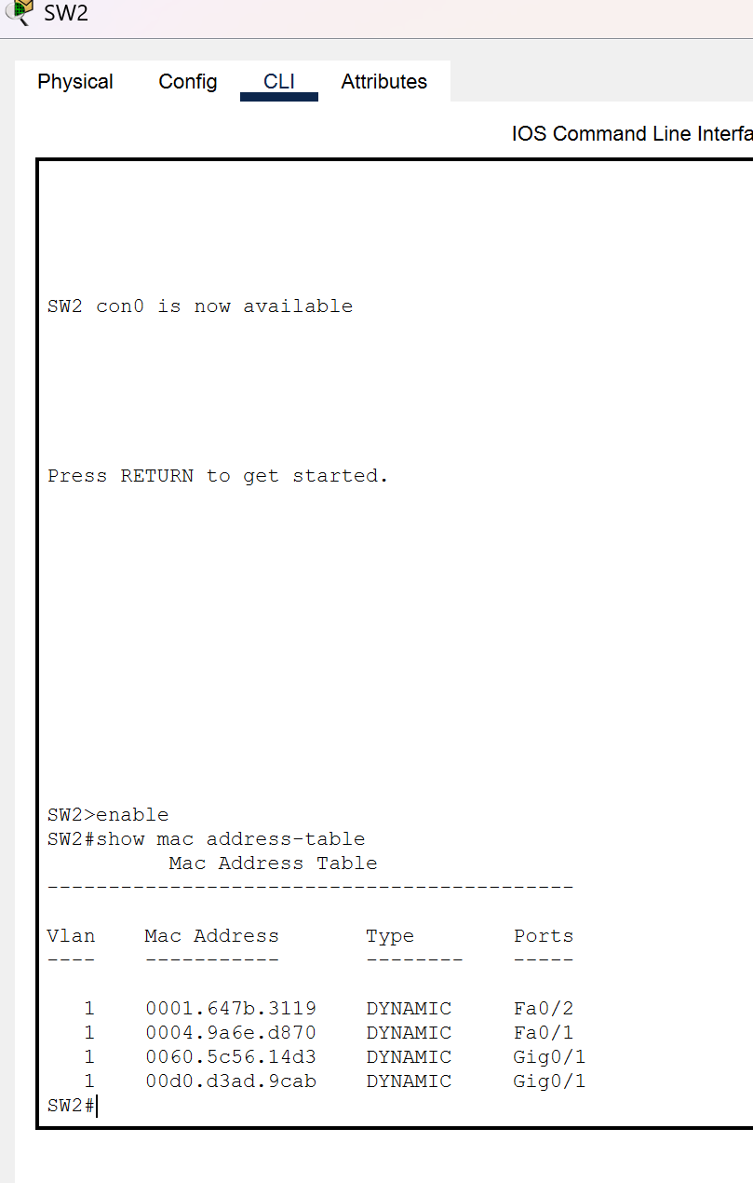
Step 5:
Switch 1
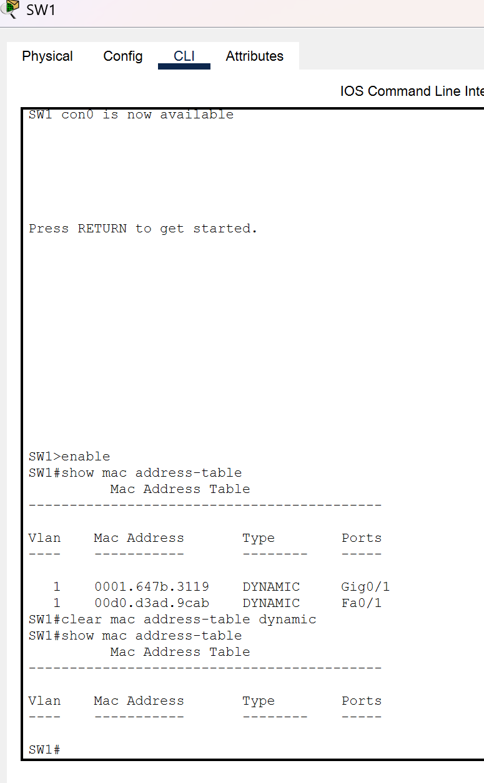
Switch 2
